1

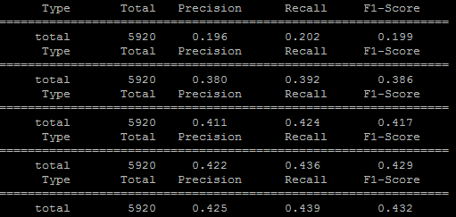

2

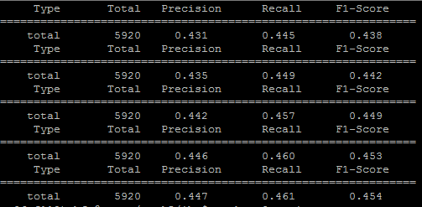

Predict：

106 1 1

106 2 2

106 6 3

106 9 4

106 3 5

106 10 6

106 9 7

106 9 8

106 8 9

106 9 10

106 10 11

Gold：

106 1 1

106 2 2

106 3 5

106 4 7

106 5 8

106 6 8

106 7 8

106 8 10

106 9 9

106 9 10

106 10 11

106 10 6

si no es así , ¿ cuándo estará en marcha ?

if not , when will it be in operation ?

|  |  |  |  |  |  |  |  |  |  |  |  |
| --- | --- | --- | --- | --- | --- | --- | --- | --- | --- | --- | --- |
|  | si | no | es | así | , | ¿ | cuándo | estará | en | marcha | ? |
| if |  |  |  |  |  |  |  |  |  |  |  |
| not |  |  |  |  |  |  |  |  |  |  |  |
| , |  |  |  |  |  |  |  |  |  |  |  |
| when |  |  |  |  |  |  |  |  |  |  |  |
| will |  |  |  |  |  |  |  |  |  |  |  |
| it |  |  |  |  |  |  |  |  |  |  |  |
| be |  |  |  |  |  |  |  |  |  |  |  |
| in |  |  |  |  |  |  |  |  |  |  |  |
| operation |  |  |  |  |  |  |  |  |  |  |  |
| ? |  |  |  |  |  |  |  |  |  |  |  |

3



106 10 11

106 6 3

106 8 9

106 9 10

106 2 2

106 1 1

106 3 5

106 4 7

106 9 8

106 5 8

106 7 8

|  |  |  |  |  |  |  |  |  |  |  |  |
| --- | --- | --- | --- | --- | --- | --- | --- | --- | --- | --- | --- |
|  | si | no | es | así | , | ¿ | cuándo | estará | en | marcha | ? |
| if |  |  |  |  |  |  |  |  |  |  |  |
| not |  |  |  |  |  |  |  |  |  |  |  |
| , |  |  |  |  |  |  |  |  |  |  |  |
| when |  |  |  |  |  |  |  |  |  |  |  |
| will |  |  |  |  |  |  |  |  |  |  |  |
| it |  |  |  |  |  |  |  |  |  |  |  |
| be |  |  |  |  |  |  |  |  |  |  |  |
| in |  |  |  |  |  |  |  |  |  |  |  |
| operation |  |  |  |  |  |  |  |  |  |  |  |
| ? |  |  |  |  |  |  |  |  |  |  |  |